

**FEDERAL URDU UNIVERSITY OF**

**ARTS SCIENCE AND TECHNOLOGY**

**KARACHI**

Department of Computer Science

Batch – 11

BS (CS) Project Report

**Islamic Application**

**Hira Qaiser** (BS/M/054/12/CS)

**Babar Khan** (BS/M/049/12/CS)

**Project Supervisor:**

**Dr. Kamran Ahsan**



**CERTIFICATE**

**This is to certify that entitled Automatic Component Handling at Various Location App submitted to Chairman of Department of Computer Science at FUUAST (Gulshan-e-Iqbal campus, Karachi) in partial fulfillment of the requirements for award of the Degree of Bachelor of Computer Science is record of the project work done by:**

**Hira Qaiser** (BS/M/1505/13/CS)

**Babar Khan** (BS/M/049/13/CS)

**Under our supervision and guidance during February 2016 to January 2017.**

**________________ _________________**

**Project Supervisor Head of Department**

"The best revenge is massive success."   
 *By Frank Sinatra*

**Acknowledgement**

We would like to express our gratitude towards our University FEDERAL URDU UNIVERSITY OF ARTS, SCIENCE AND TECHNOLOGY for allowing us to avail this opportunity to work on this project.

We are grateful to our head of the department of computer science  
PROF.MUHAMMAD SIDDIQUE who gave us the chance work in his department.

We would like to pay our greatest regards to our project supervisor  
DR. KAMRAN AHSAN for his guidance and advice during the course of the project.

Finally we would like to thank all those people who were directly or indirectly involved in making our efforts fruitful.

**AIM**

By observing the rapid growth of Android industry in our country, This Application consists of 3 modules which facilitates user (include disable person) in   
different religious perspectives. Working on Speech Recognition, Location based services and developing services required by the application.

.

* In Namaz Application, it is the disable assistant during namaz that follows the specific vibration pattern.
* Tasbeeh counter which allow to count custom/default zikar especially when you are travelling or you can count tasbeeh loudly by using speech recognition service.
* Islamic Calendar (Hijri) is an app for conversion from Gregory date to Hijri, which allows user to slide next and previous dates and months. You can set an event by clicking on the desired date .User can view Islamic and Gregory dates and month at the same time. It’s the location based calendar.

**Abstract**

This Project aims to develop An Application that is very useful for our Islamic and Muslim community.

Nowadays Pakistan has no such Islamic application that includes Namaz App, Tasbeeh Counter and Islamic Calendar 3 in 1 stuff like this.

It will help you in different perspective, In Namaz App this will help disable person during namaz and vibrates on specific namaz pattern by using speech recognition service. Once the service start it will never stop till the user/care taker stop the service.

The second module is Tasbeeh Counter, which facilitate user to count custom or select default zikkar from the list with history view facility for a user. There are two options before selecting tasbeeh from the list, automatic and manual tasbeeh counter. If user is travelling or in noisy environment there is an option of manual counter user can count tasbeeh by tapping on the screen and it will vibrates on every count or if user wants to count tasbeeh loudly there is an option of automatic tasbeeh counter this will detect spoken tasbeeh and count it. There is another feature if user say multiple times all in one breathe this application will count it multiple times too. User allow to add custom tasbeeh , Resume tasbeeh,Special vibration on completion ,Update tasbeeh and user can easily view history of recited tasbeeh that includes tasbeeh name, counting record with date and time. User allows to reset(clear) on screen record by clicking the reset button.

The last but not the least is Islamic Calendar(Hijri Calendar). We can not say that this calendar only shows the hijri dates, which allows user to slide next and previous dates and months and able to view Islamic and Gregory dates and month at the same time. You can set an event by clicking on the desired date. This calendar is location based calendar, hijri dates will automatically converts according to the location and Gregory dates too.

Table of Contents

Chapter 1: Introduction 9

Project Introduction: 9

Motivation: 10

Current System & Problems: 10

Objective: 11

Scope: 11

Methodology: 12

Namaz Application: 13

1.Start Service: 13

2.Stop Service: 13

Tasbeeh Counter: 13

A.Manual Tasbeeh: 13

B.Automatic Tasbeeh: 13

Start Button: 13

Tasbeeh List View: 13

Add Custom Tasbeeh Dialogue: 14

Arabic Translator: 14

Arabic Keyboard: 14

Add Custom Button: 14

Set Tasbeeh Counter : 14

Resume Tasbeeh: 14

UpdateTasbeeh: 14

C.Tasbehat: 15

Islamic Calendar: 15

1.Slide Left: 15

2.Slife Right: 15

Requirements: 15

Hardware & Software Requirements: 16

Hardware*:* 16

Software: 16

Chapter 2: Development 17

Technical specifications: 17

Forms: 17

Platform: 17

Android: 17

Versions: 18

Open Source Community: 19

Kernel: 19

Platform Usage: 19

Tools: 20

IDE (Integrated Development Environment): 20

Android Studio: 20

SDK (Software Development Kit): 20

Android SDK: 20

API (Application Programming Interface): 22

GSon: 22

Chapter 3: Architecture design & Implementation 24

Activity Design: 24

Application Architecture: 27

Source Code: 30

*Code Implementation:* 30

Future Scope: 35

Chapter 4: User Manual 44

Table of Contents 45

Mobile Application User Manual 46

1.Namaz App Home: 47

Required Settings: 48

2.Tasbeeh Counter:Home: 49

Pick Mode: Manual: 50

Select Tasbeeh: 51

Add Custom: 52

Arabic Translator: 53

Arabic Keyboard: 54

Set Counter: 55

Pick Mode: Automatic 56

History View 57

Reset 58

Tasbeehat 59

3.Islamic Calendar 60

Add Event 61

Chapter 5: Glossary 62

Glossary 6**2**

Chapter 1: Introduction

This chapter introduces the entire project in details. The description of the project, the features and the Scope are described in detail in this chapter.

## Project Introduction:

This Project is based on the solution for the disable assistant during namaz, Manual and Automatic tasbeeh counter with update, resume and history view of tasbeeh facility which is really hard for a user to remember every count of tasbeeh , and the view of Gregory and Hijri dates at the same time in Android phone. In World and Pakistan android is growing rapidly and has a west field of development and Ideas that fulfill the needs of entertainment & Luxuries. People now a day are busier in their life and want remote access of everything and also want an easier way for doing everything. So, here we presented a solution for the costumers and users of Android industry. The Islamic Application will help our Islamic and Muslim community and disable persons too.

People can use our Application to find a complete package of Islamic Application, there is an advantage the user will not install an application separately. Here we are trying to give user a complete package. There user will see three options Namaz App, Tasbeeh Counter and Islamic Calendar. Once user open the application after download from Google Play Store by signing Into Google I’d then user can easily select the desired option if it’s Namaz App you just need to start the service at once and this will work as a background service, or if it’s Tasbeeh counter you will see the three options manual, automatic or user wants to add custom tasbeeh only after all that you can start reciting tasbeeh with the update, resume and history view facility. The best thing about this application is that u don’t need to install multiple Islamic apps, we tried to give a complete package so that user can able to use multiple apps in one application.

## Motivation:

All human being learn from other people who are willing to share their ideas and knowledge to others. In this sense the human world is a kind of sharing network. Thinking about the final year project we were thinking of a unique, pioneer, and useful project that could make our life easy and help us in saving our time and money and also fulfills the requirements of the modern era and the latest technology. Then after thinking and discussing we have chosen the Comfort & Luxury category for our final year project.

Android industry was a strong business industry. But as time spends this industry was facing difficulties. But now in this era the Android industry is a strong business industry. It is because of the very fast invention of science, fiction and technology in the form of Computer, Minicomputer, microcomputer and nowadays phone industries made a revolutionary change in their technology by invent such a phone that calls Smartphones & Tablets .And these inventions bring major source of entertainment, joy, happiness & comfort for peoples.

## Current System & Problems:

If we talk about the world many of the Peoples worldwide are using software and Application named Islamic Calendar, tasbeeh counter, Namaz app that maybe satisfies you or maybe not but they actually will not fulfills the user requirement some hijri calendars are not accurate some tasbeeh counters contains ad but for the disable assistant there is no such application in Islamic perspective. The larger no of people want to make their smartphone really smart so here is that solution for this purpose that you don’t need install multiple applications just install one app and live smartly.

In spite of this valuable functionality of this Application there is also a problem occur which says that Internet because this application works on 24/7 internet availability due to Speech Recognition from Google activity.

## Objective:

Our main objective is to provide an easy and convenient way of the application for Muslim community. It’s the disable assistant during namaz, Manual and Automatic tasbeeh counter with update, resume and history view of tasbeeh facility which is really hard for a user to remember every count of tasbeeh , and the view of Gregory and Hijri dates at the same time.. User will use this application on any Android smartphone and tablet.

By the help of this application disable person will able to pray namaz in masjid. There is a blind concept in tasbeeh counter both able and blind person can use this application, by tapping on the screen the blind person can feel the the vibration on every count and there is a special vibration on finish tasbeeh.

## Scope:

Talking about the scope of the project we are very confident about the success of the application. (ALHAMDHULILLAH) because this is the Pakistan’s First Islamic Application that is not only for able persons but the disable persons too. There is no such Namaz assistant app for disable person, automatic tasbeeh counter and Islamic Calendar at the same app still in Pakistan. Currently the users are using application which only satisfies you for a single task. But this application will let you to use multiple Islamic apps at the same time as per your wish.

This application works on android smartphones & tablets. You just need to Install and follow the instructions on application and then no need to worry application will facilitate you.

## Methodology:

### Namaz App:

First user will see two options on very first user interface of Application to start or stop service of namaz application.

### Start Service

When caretaker click on start the service will be start on the background and it will be fully active all the time.

### Stop Service

The Service will be 24/7 active until user/caretaker stop it.

### Tasbeeh Counter:

In Tasbeeh Counter interface first user will see few options like Manual, Automatic and Tasbehat.

### Manual Tasbeeh

In this option, the user will go to the next user interface called manual tasbeeh counter where user can only do manual counting by clicking on the screen. User can view on screen tasbeeh record like total tasbeeh, left tasbeeh and total counted tasbeeh on the screen.

### Automatic Tasbeeh

In this option, the user will go to the next user interface called Automatic tasbeeh counter where user can do both manual and automatic tasbeeh counting by clicking on the screen and through speech recognition service it will automatically detect your spoken tasbeeh and count it. User can view on screen tasbeeh record like total tasbeeh, left tasbeeh and total counted tasbeeh on the screen.

### Start Button

In manual and automatic User interface of Application, user will see the start button where you can start the further process of tasbeeh. This button will go to you the next dialogue called Tasbeeh list view.

### Tasbeeh List View

When user presses start button, the tabeehat list view appears on your screen where user able to view and select default tasheeh and add custom tasbeeh too.

### Add Custom Dialogue

After pressing Add custom option in tasbeeh list view, the Add custom dialogue will appear on the screen where you will see a text box, yes and no buttons where user can add custom or no to cancel at below you will see the two checkboxes: Arabic Translation and Arabic Keyboard before adding custom tasbeeh.

### Arabic Translator

The two checkboxes user will see below the textbox, the first one is Arabic translator where user will write in Roman and it will automatically translates in Arabic just like a translator. This option will save the user time and translates immediately.

### Arabic Keyboard

By checking this option, the small popup will appear first time is add Arabic keyboard. User must add Arabic keyboard otherwise you are unable to use it. After that the Arabic keyboard will appear on the screen. If user wants to type in Arabic instead of translator.

### Add Custom button

After that if user wants to add desire tasbeeh it will be happen by pressing on the yes button this tasbeeh will automatically add on the tasbeeh list view and the next dialogue will appear on the screen called set counter limit.

### Set Tasbeeh Counter

This dialogue box will appear when user select tasbeeh from the list or add custom tasbeeh. The user has to be enter the limit of tasbeeh and press on the yes button to start the tasbeeh.

### Resume Tasbeeh

If user select the specific tasbeeh that recited once, the dialogue box will appear on the screen with the details of name of tasbeeh, date, recited tasbeeh and the two options are given Resume or Update. If user presses resume tasbeeh user will go to the main screen and it will continue your previous recited tasbeeh.

### Update Tasbeeh

The second option is update tasbeeh, if user press this option the next dialogue will be appear on the screen call set counter limit. From this option you can update previous recited tasbeeh.

### Tasbeehat

From this option if user doesn’t want to recite tasbeeh and only wants to add/save a new custom tasbeeh in the list.

### Islamic calendar:

On the very first view of Islamic calendar user will see Gregory and Hijri dates in grid view & both months with year will be displayed on the top view.

### Slide Left/ Left Button

From this user can slide left or click on the left button to see the previous dates.

### Slide Right/ Right Button

From this user can slide right or click on the right button to see the coming/next dates.

### Add Event

By clicking on the date user can add an event and the add event will screen will be appear on the screen where you can add event name, date, time etc.

## Requirements:

Requirements analysis is done in order to understand the problem, which is to be solved. That part is very important activity for the development of Application and its Schema. The requirements and the collection analysis phase produce both data requirements and functional requirements. The data requirements are used as a source from google Location map. The data requirements should be accurate for best result from an application. User will download the application from google play store. User will have to open mobile data/Wi-Fi for Namaz app otherwise the application may not work. In tasbeeh counter, if user wants to use Arabic translator he has to be open internet connectivity otherwise the result is Network Error. User must add Arabic keyboard to use Arabic keyboard in tasbeeh counter. If you are travelling user must open GPS on your mobile for Islamic Calendar.

## Hardware & Software Requirements:

### *Hardware:*

Android Smart Phones & Tablets

2G, 3G & 4G Support

1GHZ Dual Core or above

More than 750MB RAM

25MB of storage required

### *Software:*

Android Operating System

Mini version 4.0 Ice Cream Sandwich, Max version Latest Running Today

Min SDK version 16

Compile SDK version 24

Target SDK version latest, Build tool version 24.0.2.

Chapter 2: Development

In this chapter the development of the application, design and logics will discuss in detail.

## Technical specifications:

### *Forms:*

Forms that represents the graphical user interface of the application, the front end of the application which makes user feel comfortable and friendly to use the application.

### *Platform:*

The platform defines a standard around which a system can be developed. Once the platform has been defined, software developers can produce appropriate software and managers can purchase appropriate hardware and [applications](http://www.webopedia.com/TERM/A/application.html).

The Android platform is Google Inc.'s open and free [software](http://www.webopedia.com/TERM/S/software.html) stack that includes an [operating system](http://www.webopedia.com/TERM/O/operating_system.html), [middleware](http://www.webopedia.com/TERM/M/middleware.html) and also key applications for use on mobile devices, including [smartphones](http://www.webopedia.com/TERM/S/smartphone.html). Android is an Open Handset Alliance Project.

#### *Android:*

Android is the name of the mobile operating system made by American company; Google. It most commonly comes installed on a variety of smartphones and tablets from a host of manufacturers offering users access to Google’s own services like Search, YouTube, Maps, Gmail and more. This means you can easily look for information on the web, watch videos, search for directions and write emails on your phone, just as you would on your computer, but there’s more to Android than these simple examples.

*History:*Android, Inc. was founded in [Palo Alto, California](https://en.wikipedia.org/wiki/Palo_Alto,_California) in October 2003 by [Andy Rubin](https://en.wikipedia.org/wiki/Andy_Rubin) (co-founder of [Danger](https://en.wikipedia.org/wiki/Danger_(company))), [Rich Miner](https://en.wikipedia.org/wiki/Rich_Miner) (co-founder of Wildfire Communications, Inc.), Nick Sears (once VP at [T-Mobile](https://en.wikipedia.org/wiki/T-Mobile_USA)), and Chris White (headed design and interface development at [WebTV](https://en.wikipedia.org/wiki/MSN_TV)) to develop, in Rubin's words, "smarter mobile devices that are more aware of its owner's location and preferences”. The early intentions of the company were to develop an advanced operating system for [digital cameras](https://en.wikipedia.org/wiki/Digital_camera). Though, when it was realized that the market for the devices was not large enough, the company diverted its efforts toward producing a smartphone operating system that would rival [Symbian](https://en.wikipedia.org/wiki/Symbian) and Microsoft [Windows Mobile](https://en.wikipedia.org/wiki/Windows_Mobile). Despite the past accomplishments of the founders and early employees, Android Inc. operated secretly, revealing only that it was working on software for mobile phones. That same year, Rubin ran out of money. [Steve Perlman](https://en.wikipedia.org/wiki/Steve_Perlman), a close friend of Rubin, brought him $10,000 in cash in an envelope and refused a stake in the company.

##### *Versions:*

The version history of the [Android](https://en.wikipedia.org/wiki/Android_(operating_system)) [mobile operating system](https://en.wikipedia.org/wiki/Mobile_operating_system) began with the release of the Android [alpha](https://en.wikipedia.org/wiki/Alpha_(software)) in November 2007. The first commercial version, Android 1.0, was released in September 2008. Android is continually developed by [Google](https://en.wikipedia.org/wiki/Google) and the Open (OHA), and has seen a number of [updates](https://en.wikipedia.org/wiki/Patch_(computing)) to its base operating system since the initial release.

The most recent major Android update is [Android 6.0](https://en.wikipedia.org/wiki/Android_Marshmallow) "Marshmallow", which was released in October 2015. Since April 2009, Android versions have been developed under a [confectionery](https://en.wikipedia.org/wiki/Confectionery)-themed [code name](https://en.wikipedia.org/wiki/Code_name) and released in alphabetical order, beginning with Android 1.5 "Cupcake"; the earlier versions 1.0 and 1.1 were not released under specific code names.

* Android 1.5 Cupcake
* Android 1.6 Donut
* Android 2.1 Eclair
* Android 2.2 Froyo
* Android 2.3 Gingerbread
* Android 3.2 Honeycomb - The first OS design specifically for a tablets, launching on the Motorola Xoom
* Android 4.0 Ice Cream Sandwich: The first OS to run on smartphones and tablets, ending the 2.X naming convention.
* Android 4.1 Jelly Bean: Launched on the Google Nexus 7 tablet by Asus
* Android 4.2 Jelly Bean: Arrived on the LG Nexus 4
* Android 4.3 Jelly Bean
* Android 4.4 KitKat: Launched on the LG Nexus 5
* Android 5.0 Lollipop: Launched on the Motorola Nexus 6 and HTC Nexus 9
* Android 6.0 Marshmallow: Launched on the LG Nexus 5X and Huawei Nexus 6P
* Android 7.0 Nougat: Launched on the Samsung Galaxy S7 Edge and Huawei P9

##### *Open Source Community:*

Android has an active community of developers and enthusiasts who use the Android Open Source Project (AOSP) source code to develop and distribute their own modified versions of the operating system. These community-developed releases often bring new features and updates to devices faster than through the official manufacturer/carrier channels, with a comparable level of quality; provide continued support for older devices that no longer receive official updates; or bring Android to devices that were officially released running other operating systems, such as the [HP Touchpad](https://en.wikipedia.org/wiki/HP_TouchPad). Community releases often come pre-[rooted](https://en.wikipedia.org/wiki/Android_rooting) and contain modifications not provided by the original vendor, such as the ability to [overclock](https://en.wikipedia.org/wiki/Overclock) or [over/](https://en.wikipedia.org/wiki/Dynamic_voltage_scaling)undervolted the device's processor. [Cyanogen Mod](https://en.wikipedia.org/wiki/CyanogenMod) is the most widely used community firmware, and acts as a foundation for numerous others. There have also been attempts with varying degrees of success to port Android to iPhones, notably the I Droid Project.

##### *Kernel:*

Android's [kernel](https://en.wikipedia.org/wiki/Kernel_(computing)) is based on one of the [Linux kernel](https://en.wikipedia.org/wiki/Linux_kernel)'s [long-term support](https://en.wikipedia.org/wiki/Long-term_support) (LTS) branches. Since April 2014, Android devices mainly use versions 3.4 or 3.10 of the Linux kernel. The specific kernel version depends on the actual Android device and its hardware platform. Android has used various kernel versions since the version 2.6.25 that was used in Android 1.0.

##### 

##### *Platform Usage:*

Charts in this section provide breakdowns of Android versions, based on devices accessing the [Google Play Store](https://en.wikipedia.org/wiki/Google_Play_Store) in a seven-day period ending on February 1, 2016. Therefore, these statistics exclude devices running various Android [forks](https://en.wikipedia.org/wiki/Fork_(software_development)) that do not access the Google Play Store, such as Amazon's [Fire tablets](https://en.wikipedia.org/wiki/Kindle_Fire).

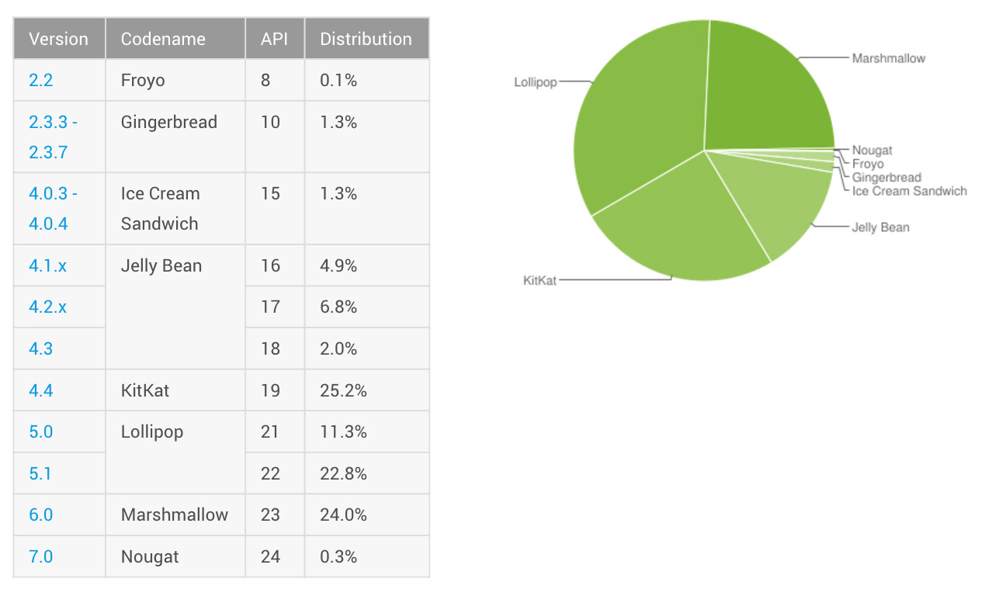

## Tools:

Formerly the official IDE solution for Android development, Android Developer Tools (ADT) is a plugin for Eclipse that provides GUI-based access to many of the command-line SDK tools, along with a UI design tool for rapid prototyping, designing, and building of your app's user interface.

### *IDE (Integrated Development Environment):*

An integrated development environment (IDE) is a programming environment that has been packaged as an application program, typically consisting of a code editor, a compiler, a debugger, and a graphical user interface (GUI) builder.

#### *Android Studio:*

Android Studio is the official [integrated development environment](https://en.wikipedia.org/wiki/Integrated_development_environment) (IDE) for developing for the [Android](https://en.wikipedia.org/wiki/Android_(operating_system)) platform. It was announced on May 16, 2013 at the [Google I/O](https://en.wikipedia.org/wiki/Google_I/O) conference. Android Studio is freely available under the [Apache License 2.0](https://en.wikipedia.org/wiki/Apache_License).

Android Studio was in early access preview stage starting from version 0.1 in May 2013, then entered beta stage starting from version 0.8 which was released in June 2014. The first stable build was released in December 2014, starting from version 1.0.

Based on [Jet Brains](https://en.wikipedia.org/wiki/JetBrains)' [IntelliJ IDEA](https://en.wikipedia.org/wiki/IntelliJ_IDEA) software, Android Studio is designed specifically for Android development. It is available for download on [Windows](https://en.wikipedia.org/wiki/Windows), [Mac OS X](https://en.wikipedia.org/wiki/Mac_OS_X) and [Linux](https://en.wikipedia.org/wiki/Linux), and replaced [Eclipse Android Development Tools](https://en.wikipedia.org/wiki/Eclipse_(software)#Eclipse_ADT_.28Android_Development_Tools.29) (ADT) as Google's primary IDE for native Android application development.

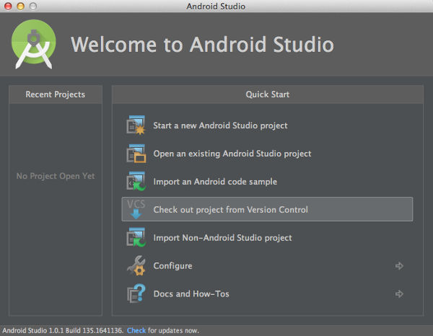

### *SDK (Software Development Kit):*

A software development kit (SDK or "dev kit") is typically a set of software development tools that allows the creation of applications for a certain software package, software framework, hardware platform, computer system, video game console, operating system, or similar development platform.

#### *Android SDK:*

The Android [software development kit](https://en.wikipedia.org/wiki/Software_development_kit) (SDK) includes a comprehensive set of development tools. These include a debugger, libraries, a handset [emulator](https://en.wikipedia.org/wiki/Emulator) based on [QEMU](https://en.wikipedia.org/wiki/QEMU), documentation, sample code, and tutorials. Currently supported development platforms include computers running [Linux](https://en.wikipedia.org/wiki/Linux_kernel) (any modern desktop [Linux distribution](https://en.wikipedia.org/wiki/List_of_Linux_distributions)), [Mac OS X](https://en.wikipedia.org/wiki/Mac_OS_X) 10.5.8 or later, and [Windows XP](https://en.wikipedia.org/wiki/Windows_XP) or later. As of March 2015, the SDK is not available on Android itself, but the software development is possible by using specialized Android applications. Fiphone

SYNTAX:

<uses-sdk android:[minSdkVersion](http://developer.android.com/guide/topics/manifest/uses-sdk-element.html#min)="*integer*"  
          android:[targetSdkVersion](http://developer.android.com/guide/topics/manifest/uses-sdk-element.html#target)="*integer*"  
          android:[maxSdkVersion](http://developer.android.com/guide/topics/manifest/uses-sdk-element.html#max)="*integer*" />

Run Time Check for Android Version & SDK

If (Android.OS.Build.Version.SdkInt >= Android.OS.BuildVersionCodes.Lollipop)

{

builder.SetCategory (Notification.CategoryEmail);

}

“Nougat".

The Android version, such as Android 7.0  
The API level (SDK), such as "API Level 24"

“Marshmallow".

The Android version, such as Android 6.0  
The API level (SDK), such as "API Level 23"

"Lollipop".  
The Android version, such as Android 5.1  
The API level (SDK), such as "API Level 22"

"Lollipop".  
The Android version, such as Android 5.0  
The API level (SDK), such as "API Level 21"

"KitKat".  
The Android version, such as Android 4.4  
The API level (SDK), such as "API Level 19, 20"

"Jellybeans".

The Android version, such as Android 4.3  
The API level (SDK), such as "API Level 18"

"Jellybeans".

The Android version, such as Android 4.2  
The API level (SDK), such as "API Level 17"

"Jellybeans".

The Android version, such as Android 4.1  
The API level (SDK), such as "API Level 16"

"Ice Cream Sandwich".  
The Android version, such as Android 4.0  
The API level (SDK), such as "API Level 15, 14"

"Honeycomb".

The Android version, such as Android 3.2  
The API level (SDK), such as "API Level 13"

"Gingerbread".

The Android version, such as Android 2.3  
The API level (SDK), such as "API Level 9".

### *API (Application Programming Interface):*

API (application program interface) is a set of routines, protocols, and tools for building software applications. The API specifies how software components should interact and APIs are used when programming graphical user interface (GUI) components.

#### *GSon:*

Gson is a Java library that can be used to convert Java Objects into their JSON representation. It can also be used to convert a JSON string to an equivalent Java object. Gson can work with arbitrary Java objects including pre-existing objects that you Do not have source-code of. The primary class to use is [Gson](http://code.google.com/p/google-gson/source/browse/trunk/gson/src/main/java/com/google/gson/Gson.java) which you can just create by calling new Gson (). There is also a class [Gson Builder](http://code.google.com/p/google-gson/source/browse/trunk/gson/src/main/java/com/google/gson/GsonBuilder.java) available that can be used to create a Gson instance with various settings like version control and soon. The Gson instance does not maintain any state while invoking J-Son operations. So, you are free to reuse the same object for multiple J-Son serialization and deserialization operations.

The Library requires **Android SDK version 9 (Gingerbread)** and higher. Gradle Dependency: dependencies {

Compile 'com.github.shell-software: fab: 1.1.2’

}

**Action Button** has a dependency on an external [**View Mover**](https://github.com/shell-software/view-mover) library, which in turn has a transitive dependency on the [**UI Tools**](https://github.com/shell-software/uitools) library. If any of these libraries are already used in the project they must be excluded as transitive dependencies.

Declaration inside XML Resource:

<RelativeLayout

xmlns:android="http://schemas.android.com/apk/res/android"

xmlns:fab="http://schemas.android.com/apk/res-auto"

Android: layout width="match_parent"

Android: layout height="match_parent"

>

<com.software.shell.fab.ActionButton

android:id="@+id/action_button"

Android: layout width="wrap_content"

Android: layout height="wrap_content"

Android: layout_alignParentBottom="true"

Android: layout_alignParentRight="true"

android:layout_marginRight="@dimen/fab_margin"

android:layout_marginBottom="@dimen/fab_margin"

/>

</RelativeLayout>

Chapter 3: Architecture design & Implementation

In this chapter the architecture, design & implementation of whole Project will discuss thoroughly.

## Activity Design:

We have designed an activity part of our app through which we can easily explain that what are the activity occur while using our app, and what benefit it have after using it. It includes very summarize neat and easy processes. Activity diagrams are as follows:

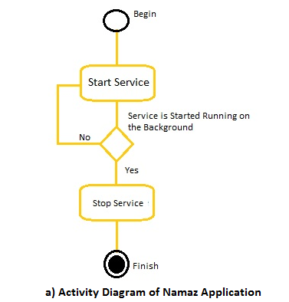

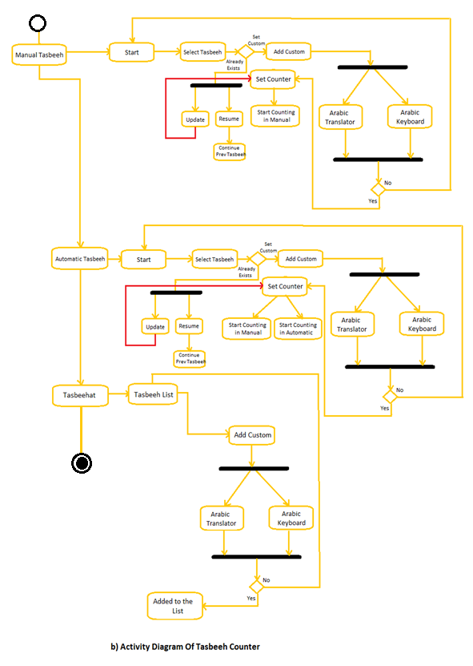

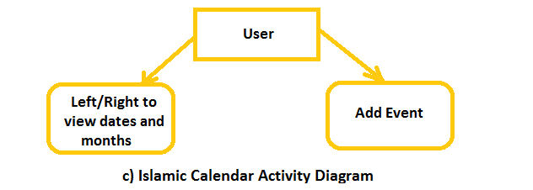

## Application Architecture:

The Working Architecture of Namaz application is that the caretaker of a disable person start the service once and give it to the disable person. Once the service start it will automatically detect correct Namaz pattern and through vibration it will assist disable person on different stages of Namaz.

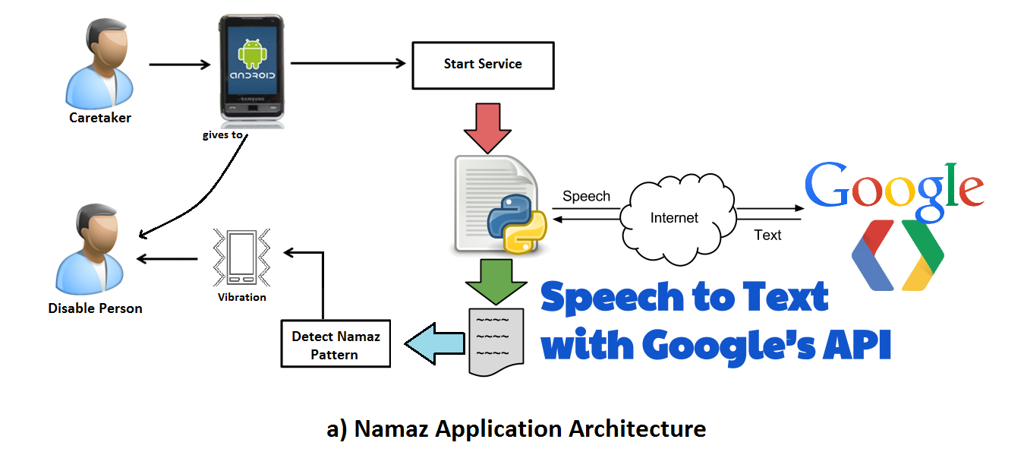

In the architecture of tasbeeh counter, on the very first view user will select the tasbeeh mode automatic or manual. If it is manual user will start tasbeeh from the list and if it is new it will added to the database/ if you recited once it will ask for update/resume tasbeeh. After selecting tasbeeh by touching on the screen you can count it. If user selected automatic mode then you can use both features in this mode by tapping on the screen and through voice you can count your selected tasbeeh. User can add custom tasbeeh without selecting manual or automatic mode. In Add custom dialogue here you can type Arabic tasbeeh through keyboard or translator too.

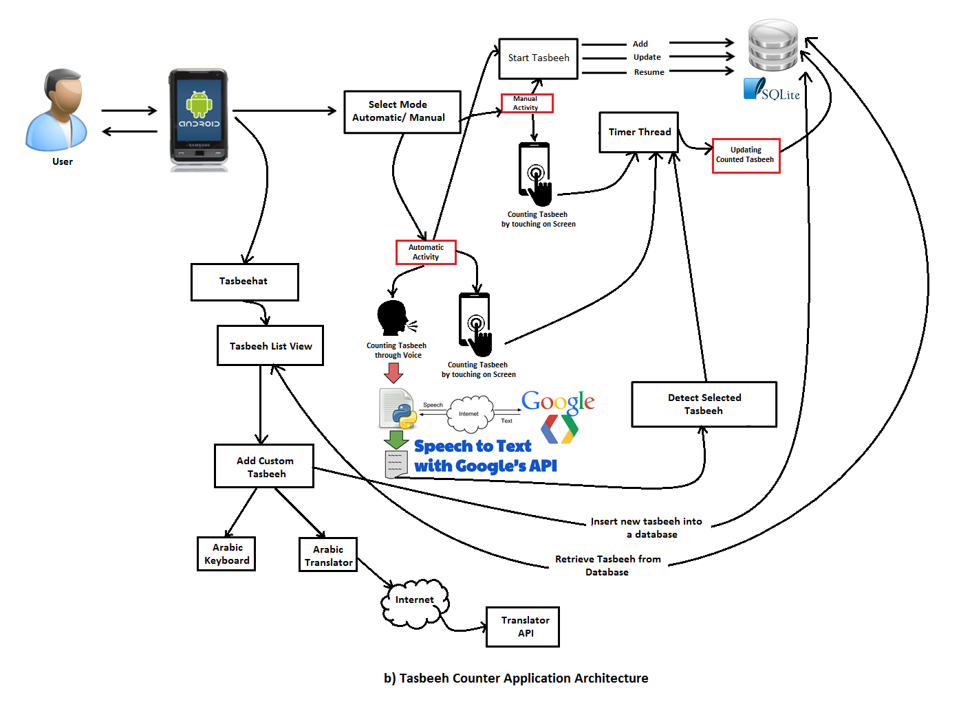

The architecture of Islamic calendar shows the background process in which fragment is created and dates conversion with the help of libraries. User can sync this calendar with location though Google Location Service (GPS) and add events.

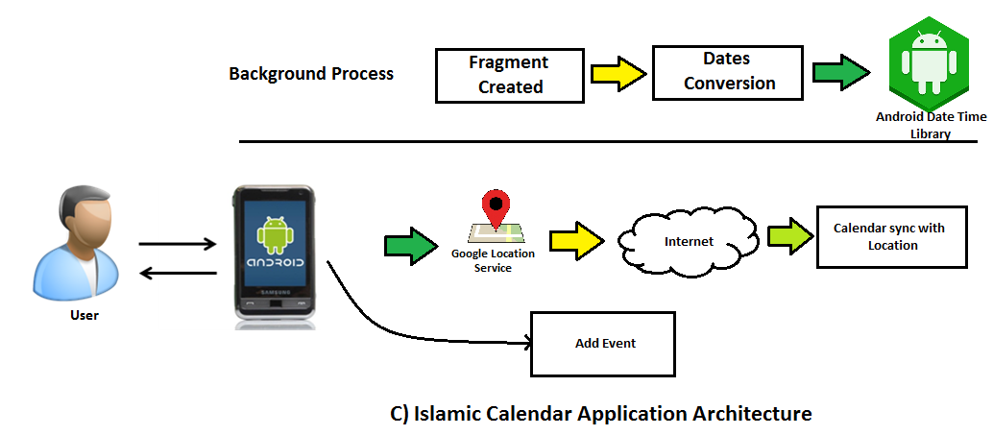

## Source Code:

Source code and object code refer to the "before" and "after" versions of a computer program that is compiled (see [compiler](http://whatis.techtarget.com/definition/compiler)) before it is ready to run in a computer. The source code consists of the programming statements that are created by a programmer with a [text editor](http://whatis.techtarget.com/definition/text-editor) or a visual programming tool and then saved in a file.

### *Code Implementation For Namaz App:*

This project was created using Android Studio 2.2.  
There are seven source code files in the starter project; take a moment to familiarize yourself with them.

* **ArabicWordsArrayList.java:** a class which contains all stages for namaz in Arabic words.
* **PatternList.java:** a class which contains unique vibration pattern for namaz.
* **MainActivity.java:** a main class which contains start or stop service listener.
* **VoiceService.java:** a Service where Arabic speech will be detected**.**

The following build settings have been specified in build.gradle, and you should make sure you have the corresponding Android SDK packages installed:

* minSdkVersion: 16
* compileSdkversion: 24
* targetSdkVersion: 24
* buildToolsVersion: 24.0.2

The starter project defined in build.gradle; the app includes the Card View and RecyclerView classes from the [Android Support Library](http://developer.android.com/tools/support-library/index.html) along with two third-party libraries: [Gson](https://github.com/google/gson), for serializing objects to JSON, and [FAB](https://github.com/shell-software/fab), a library used to display a floating action button.

Emulator that will work with Google Play Services, choose Tools\Android\AVD Manager from the Android Studio menu.

Choose an API Level of 24 as this is the latest version. For the best emulator performance, use an ABI of x86 or x86_64 if you have HAXM installed. If you don’t have HAXM, choose armebi-v7a for the ABI.

The package is one of the dependencies listed in build.gradle:

dependencies {  
 compile fileTree(dir: **'libs'**, include: [**'*.jar'**])  
 androidTestCompile(**'com.android.support.test.espresso:espresso-core:2.2.2'**, {  
 exclude group: **'com.android.support'**, module: **'support-annotations'** })  
 compile **'com.android.support:appcompat-v7:24.2.0'** testCompile **'junit:junit:4.12'**}

MainActivity code:

**private void** initialize() {  
  
 *// Start receiver with the name StartupReceiver_Manual_Start  
 // Check AndroidManifest.xml file* getBaseContext().getApplicationContext().sendBroadcast(  
 **new** Intent(**"StartupReceiver_Manual_Start"**));  
}  
**public void** startService (View v){  
  
  
  
 initialize();  
 Intent i=**new** Intent(**this**,VoiceService.**class**);  
 startService(i);  
  
  
}  
  
**public void** stopService (View v){  
 Intent i=**new** Intent(**this**,VoiceService.**class**);  
 stopService(i);  
}

Here is the code of speech recognition service:

**public void** onStart() {  
  
 **if** (**sr** != **null**) {  
 Log.*d*(**"22222222"**, **"Destroy"**);  
 **sr**.destroy();  
 }  
  
  
  
  
 **sr** = SpeechRecognizer.*createSpeechRecognizer*(**this**);  
 **sr**.setRecognitionListener(**new** listener());  
  
  
  
 Intent intent = **new** Intent(RecognizerIntent.***ACTION_RECOGNIZE_SPEECH***);  
 intent.putExtra(RecognizerIntent.***EXTRA_LANGUAGE_MODEL***, RecognizerIntent.***LANGUAGE_MODEL_FREE_FORM***);  
  
  
 intent.putExtra(RecognizerIntent.***EXTRA_LANGUAGE_MODEL***, **"ar-SA"**);  
  
 intent.putExtra(**"android.speech.extra.EXTRA_ADDITIONAL_LANGUAGES"**, **new** String[]{**"ar-SA"**});  
 intent.putExtra(RecognizerIntent.***EXTRA_LANGUAGE_PREFERENCE***, **"ar-SA"**);  
 intent.putExtra(RecognizerIntent.***EXTRA_ONLY_RETURN_LANGUAGE_PREFERENCE***, **"ar-SA"**);  
  
 intent.putExtra(RecognizerIntent.***EXTRA_MAX_RESULTS***, 5);  
  
  
 AudioManager amanager=(AudioManager)getSystemService(Context.***AUDIO_SERVICE***);  
 amanager.setStreamMute(AudioManager.***STREAM_NOTIFICATION***, **true**);  
 amanager.setStreamMute(AudioManager.***STREAM_ALARM***, **true**);  
 amanager.setStreamMute(AudioManager.***STREAM_MUSIC***, **true**);  
 amanager.setStreamMute(AudioManager.***STREAM_RING***, **true**);  
 amanager.setStreamMute(AudioManager.***STREAM_SYSTEM***, **true**);  
 **sr**.startListening(intent);  
  
 Log.*i*(**"111111"**, **"11111111"**);  
  
  
}

### *Code Implementation For Tasbeeh Counter:*

This project was created using Android Studio 2.2.  
There are seven source code files in the starter project; take a moment to familiarize yourself with them.

* **ArabicWordsArrayList.java:** a class which contains all tasbeehat in Arabic words.
* **CustomZikar.java:** a dialogue where you can add custom tasbeeh.
* **DataBaseHelper.java:** a database where all records save in the database.
* **HistoryView.java:** an Activity that displays all records of tasbeeh**.**
* **MainActivity.java:** an Activity that displays the counter view**.**
* **MainMenu.java:** an Activity which is the very first view when activity starts that displays multiple options of tasbeehat.
* **Manual Tasbeeh.java:** an Activity where you can recite tasbeeh only in manual**.**
* **ArabicKeyboard.java:** a Fragment that displays Arabic keyboard in custom zikar**.**
* **Translator.java:** a class where translator API calls**.**
* **VoiceService.java:** a Service where Arabic speech will be detected**.**
* **ZikarList.java:** a dialogue that displays list view of zikkar**.**
* **UpdateResume.java:** a dialogue where you can update or resume tasbeeh**.**
* **CounterLimit.java:** a dialogue where you can add total zikkar that you will going to be reciting.

The following build settings have been specified in build.gradle, and you should make sure you have the corresponding Android SDK packages installed:

* minSdkVersion: 16
* compileSdkversion: 24
* targetSdkVersion: 24
* buildToolsVersion: 24.0.2

The starter project defined in build.gradle; the app includes the Card View and RecyclerView classes from the [Android Support Library](http://developer.android.com/tools/support-library/index.html) along with two third-party libraries: [Gson](https://github.com/google/gson), for serializing objects to JSON, and [FAB](https://github.com/shell-software/fab), a library used to display a floating action button.

Emulator that will work with Google Play Services, choose Tools\Android\AVD Manager from the Android Studio menu.

Choose an API Level of 24 as this is the latest version. For the best emulator performance, use an ABI of x86 or x86_64 if you have HAXM installed. If you don’t have HAXM, choose armebi-v7a for the ABI.

The package is one of the dependencies listed in build.gradle:

dependencies {  
 compile fileTree(dir: **'libs'**, include: [**'*.jar'**])  
 androidTestCompile(**'com.android.support.test.espresso:espresso-core:2.2.2'**, {  
 exclude group: **'com.android.support'**, module: **'support-annotations'** })  
 compile **'com.android.support:appcompat-v7:24.2.0'** testCompile **'junit:junit:4.12'**}

Manual Tasbeeh Counter Activity Code:

**protected void** onCreate(Bundle savedInstanceState) {  
 **super**.onCreate(savedInstanceState);  
 setContentView(R.layout.***activity_manual_tasbeeh***);  
 **textView**=(TextView)findViewById(R.id.***textView2***);  
 textView6=(TextView)findViewById(R.id.***textView6***);  
 *// textView5=(TextView)findViewById(R.id.textView5);* CustomZikar();  
 *// counterlimit();* RelativeLayout rl=(RelativeLayout)findViewById(R.id.***relative***);  
  
 rl.setOnClickListener(**new** View.OnClickListener(){  
 @Override  
 **public void** onClick(View v) {  
 myvar1.*mycounter*++;  
 **textView**.setText(String.*valueOf*(myvar1.*mycounter*));  
 }  
});  
  
  
}

History View Activity:

@Override  
 **protected void** onCreate(Bundle savedInstanceState) {  
 **super**.onCreate(savedInstanceState);  
 setContentView(***activity_history_view***);  
 **final** DataBaseHelper db = **new** DataBaseHelper(**this**);  
 *// GridView gv = (GridView) findViewById(R.id.gridView);* getdata();  
  
  
 }  
   
  
 **public void** getdata() {  
  
 **final** DataBaseHelper db = **new** DataBaseHelper(**this**);  
 */////////////////////////////////////////////////////////////////////////////////////* TableLayout tableLayout = (TableLayout) findViewById(R.id.***tableLayout***);  
 *// tv.removeAllViewsInLayout();* **int** flag = 1;  
  
 TableRow tr = **new** TableRow(HistoryView.**this**);  
  
  
 Cursor res = db.getHistory();  
 **if** (res.getCount() == 0) {  
  
 } **else** {  
 TableRow rowHeader = **new** TableRow(HistoryView.**this**);  
 rowHeader.setBackgroundColor(Color.*parseColor*(**"#c0c0c0"**));  
 rowHeader.setLayoutParams(**new** TableLayout.LayoutParams(TableLayout.LayoutParams.***MATCH_PARENT***,  
 TableLayout.LayoutParams.***MATCH_PARENT***));  
 String[] headerText={**"Zikar"**,**"Counter"**,**"Left"**,**"Total"** ,**"Status"**};  
 **for**(String c:headerText) {  
 TextView tv = **new** TextView(**this**);  
 tv.setLayoutParams(**new** TableRow.LayoutParams(TableRow.LayoutParams.***MATCH_PARENT***,  
 TableRow.LayoutParams.***MATCH_PARENT***));  
 tv.setGravity(Gravity.***LEFT***);  
 tv.setTextSize(16);  
 tv.setPadding(6, 6, 6, 6);  
 tv.setText(c);  
 rowHeader.addView(tv);  
 }  
 tableLayout.addView(rowHeader);  
  
 }  
  
 *// history.clear();* StringBuffer buffer = **new** StringBuffer();  
 **while** (res.moveToNext()) {  
 *// buffer.append(res.getString(0) );  
  
 // buffer.append(res.getString(1));  
 //buffer.append(res.getString(2));  
 //buffer.append(res.getString(3));  
 // buffer.append(res.getString(3));* String id = res.getString(1) + **" "** + res.getString(2) + **" "** + res.getString(3) +**" "** + res.getString(4) +**" "** + res.getString(5)+ **"\n"**;  
 **history**.add(id);  
 *// data.add(datanum);* **try** {  
  
  
 *// this will be executed once  
  
  
/////////////////////////////////////////////////////////////////////////////////////////* TableRow row = **new** TableRow(HistoryView.**this**);  
 row.setLayoutParams(**new** TableLayout.LayoutParams(TableLayout.LayoutParams.***MATCH_PARENT***,  
 TableLayout.LayoutParams.***MATCH_PARENT***));  
 String[] colText = {res.getString(1) + **""**, res.getString(2), res.getString(3),res.getString(4),res.getString(5)};  
 **for** (String text : colText) {  
 TextView tv = **new** TextView(**this**);  
 tv.setLayoutParams(**new** TableRow.LayoutParams(TableRow.LayoutParams.***MATCH_PARENT***,  
 TableRow.LayoutParams.***MATCH_PARENT***));  
 tv.setGravity(Gravity.***LEFT***);  
 tv.setTextSize(15);  
 tv.setPadding(5, 5, 5, 5);  
 tv.setWidth(20);  
 tv.setText(text);  
 row.addView(tv);  
  
 }  
 tableLayout.addView(row);  
  
  
 }  
  
 **catch** (Exception e) {  
 Log.*e*(**"log_tag"**, **"Error parsing data "** + e.toString());  
 Toast.*makeText*(getApplicationContext(), **"JsonArray fail"**, Toast.***LENGTH_SHORT***).show();  
 }  
  
  
 }  
 }

Tasbeeh zikkar list dialogue code:

**public void TasbeehList**Dialog() {  
 **final** Context context = **this**;  
 **final** Dialog dialog = **new** Dialog(context);  
 dialog.setContentView(R.layout.***activity_zikar_list***);  
 dialog.setTitle(**"Select Tasbeeh:"**);  
 **lv** = (ListView) dialog.findViewById(R.id.***listView***);  
 *zikkar* = **new** ArabicWordsArraylists().getArrayList1();  
  
 **try** {  
 Cursor res = **myDB**.getlist();  
 **if** (res.getCount() != 0) {  
 *// history.clear();* StringBuffer buffer = **new** StringBuffer();  
 **while** (res.moveToNext()) {  
 buffer.append(res.getString(1));  
 String xx = res.getString(1).toString();  
 *// mylist.add(xx);  
 zikkar*.add(xx);  
  
 }  
 }  
  
 ArrayAdapter<String> aa = **new** ArrayAdapter<String>(context, android.R.layout.***simple_list_item_1***, *zikkar*);  
 **lv**.setAdapter(aa);  
 **lv**.setOnItemClickListener(**new** AdapterView.OnItemClickListener() {  
 @Override  
 **public void** onItemClick(AdapterView<?> adapterView, View view, **int** i, **long** l) {  
  
  
 myvar.*myposition* = i;  
  
 **if** (myvar.*selectedZikar* != **null** && myvar.*myposition* != 13) {  
  
 Cursor res = **myDB**.SelectResume(myvar.*selectedZikar*);  
 **if** (res.getCount() == 0) {  
 Toast.*makeText*(MainActivity.**this**, **"No Data Available"**, Toast.***LENGTH_SHORT***).show();  
 dialog.cancel();  
 counterlimit();  
 }  
 **else** {  
  
 *// history.clear();* StringBuffer buffer = **new** StringBuffer();  
 **while** (res.moveToNext()) {  
 myvar.*zc*=res.getInt(3);  
  
  
 myvar.*Message* = **"Recited:"** + res.getString(3).toString() + **" At:"** + res.getString(4).toString() + **" "** + res.getString(5).toString();  
}  
  
 }  
  
  
 **if** ( myvar.*zc*!=0) {  
  
 ResumeDialoge();  
 dialog.cancel();  
  
  
 }  
  
 }  
 **if** (*zikkar*.get(i).toString().contains(**"Add Custom"**)) {  
 myvar.*selectedZikar*=**""**;  
 CustomZikar();  
  
 dialog.cancel();  
  
  
 }  
  
 }  
 });  
  
 dialog.show();  
  
  
 } **catch** (Exception e) {  
 e.printStackTrace();  
 }  
}

Arabic List Class:

**public class** ArabicWordsArraylists {  
  
 ArrayList<String> **arrayList1**, **arrayList2**;  
 ArrayList **Array1**,**Array2**,**Array3**,**Array4**,**Array5**,**Array6**,**Array7**,**Array8**,**Array9**,**Array10**,**Array11**,**Array12**,**Array13**;  
  
 **public** ArrayList getArrayList1() {  
 **arrayList1** = **new** ArrayList();  
  
 **arrayList1**.add(**"الله اكبر"**);  
 **arrayList1**.add(**"سبحان الله و بحمده"**);  
 **arrayList1**.add(**"سبحان الله العظيم وبحمدهِِ"**);  
 **arrayList1**.add(**"سبحان الله العظيم"**);  
 **arrayList1**.add(**"سبحان اللهِِ"**);  
 **arrayList1**.add(**"سبحان الله و الحمد لله و لا اله الا الله و الله اكبرُِ"**);  
 **arrayList1**.add(**"الحمد لله"**);  
 **arrayList1**.add(**"لا اله الا الله"**);  
 **arrayList1**.add(**"لاحول ولاقوه الا بالله العلي العظيم"**);  
 **arrayList1**.add(**"استغفر الله"**);  
 **arrayList1**.add(**" لا اله الا الله محمد رسول الله"**);  
 **arrayList1**.add(**"لاَّ إِلَـهَ إِلاَّ أَنتَ سُبْحَـنَكَ إِنِّى كُنتُ مِنَ الظَّـلِمِينَِ"**);  
 **arrayList1**.add(**"اللَّهُمَّ صَلِّ عَلَى مُحَمَّدٍ وَعَلَى آلِ مُحَمَّدٍ"**);  
 **arrayList1**.add(**"Add Custom"**);  
  
 **return arrayList1**;  
 }

}

### *Code Implementation For ISlamic Calendar:*

This project was created using Android Studio 2.2.  
There are seven source code files in the starter project; take a moment to familiarize yourself with them.

* **CaldroidFragment.java:** a dialogue fragment which contains all setup view.
* **CaldroidGridAdapter.java:** that provides customized view for the dates gridview.
* **CaldroidListener.java:** a listener that informs when user clicks on a valid date.
* **CaldroidSampleActivity.java:** a fragment activity which contains all setup of fragment when fragment created**.**
* **CaldroidSampleCustomAdapter.java:** a caldroid grid adapter in which there is a setup for mapping dates in a particular grid with position.
* **CalendarHelper.java:** a class where you will retrieve all the dates for a given calendar month Include previous month, current month and next month**.**
* **CurrentTimeAPI.java:** a class where you can get current date and time using GPS**.**
* **DateGridFragment.java:** a fragment which provides the fragment and onitemclicklistener before the fragment is attached**.**
* **GPSTracker:** a location listener, this class is used for to determine and track its precise location**.**
* **HijriCalendarDate:** a class which returns the hijri date**.**
* **InfinitePagerAdapter.java:** a calendar pager adapter**.**
* **InfiniteViewPager.java:** that allows infinite paging effect with wrap around effect by using infinite pager adapter.
* **MonthPagerAdapter.java:** a fragment pager adapter, this will provide 4 grid views for month which includes: next,previous,current and 1 extra for fragment recycle.
* **ArabicNumbers.java:** a class which displays hijri dates in Arabic view.
* **SquareTextView.java:** a textview that generates for the date cell.
* **WeekdayArrayAdapter.java:** an Array adapter, it will customize the weekday gridview.

The following build settings have been specified in build.gradle, and you should make sure you have the corresponding Android SDK packages installed:

* minSdkVersion: 16
* compileSdkversion: 24
* targetSdkVersion: 24
* buildToolsVersion: 24.0.2

The starter project defined in build.gradle; the app includes the Card View and RecyclerView classes from the [Android Support Library](http://developer.android.com/tools/support-library/index.html) along with two third-party libraries: [Gson](https://github.com/google/gson), for serializing objects to JSON, and [FAB](https://github.com/shell-software/fab), a library used to display a floating action button.

Emulator that will work with Google Play Services, choose Tools\Android\AVD Manager from the Android Studio menu.

Choose an API Level of 24 as this is the latest version. For the best emulator performance, use an ABI of x86 or x86_64 if you have HAXM installed. If you don’t have HAXM, choose armebi-v7a for the ABI.

Here we add date library, the package is one of the dependencies listed in build.gradle:

dependencies {  
 androidTestCompile(**'com.android.support.test.espresso:espresso-core:2.2.2'**, {  
 exclude group: **'com.android.support'**, module: **'support-annotations'** compile **'com.android.support:appcompat-v7:23.0.0'** })  
 testCompile **'junit:junit:4.12'** compile files(**'libs/date4j.jar'**)  
}

Caldroid Calendar class:

@Override  
**public** View onCreateView(LayoutInflater inflater, ViewGroup container,  
 Bundle savedInstanceState) {  
 retrieveInitialArgs();  
  
 **if** (getDialog() != **null**) {  
 setRetainInstance(**true**);  
 }  
  
 View view = inflater.inflate(R.layout.***calendar_view***, container, **false**);  
   
  
 **hijrimonthTitleTextView** = (TextView) view  
 .findViewById(R.id.***hijri_month_year_textview***);  
  
**monthTitleTextView** = (TextView) view  
 .findViewById(R.id.***calendar_month_year_textview***);  
   
 **leftArrowButton** = (Button) view.findViewById(R.id.***calendar_left_arrow***);  
 **rightArrowButton** = (Button) view  
 .findViewById(R.id.***calendar_right_arrow***);  
  
**leftArrowButton**.setOnClickListener(**new** OnClickListener() {  
  
 @Override  
 **public void** onClick(View v) {  
 prevMonth();  
 }  
 });  
  
**rightArrowButton**.setOnClickListener(**new** OnClickListener() {  
  
 @Override  
 **public void** onClick(View v) {  
 nextMonth();  
 }  
 });  
  
 setShowNavigationArrows(**showNavigationArrows**);  
  
**weekdayGridView** = (GridView) view.findViewById(R.id.***weekday_gridview***);  
 WeekdayArrayAdapter weekdaysAdapter = getNewWeekdayAdapter();  
 **weekdayGridView**.setAdapter(weekdaysAdapter);  
  
 setupDateGridPages(view);  
  
 refreshView();  
  
**if** (**caldroidListener** != **null**) {  
 **caldroidListener**.onCaldroidViewCreated();  
 }  
  
 **return** view;  
}

GPSTracker class:

**public class** GPSTracker **extends** Service **implements** LocationListener {  
  
 **private** Context **mContext**;  
  
 *// flag for GPS status* **public boolean isGPSEnabled** = **false**;  
  
 *// flag for network status* **boolean isNetworkEnabled** = **false**;  
  
 *// flag for GPS status* **boolean canGetLocation** = **false**;  
  
 Location **location**; *// location* **double latitude**; *// latitude* **double longitude**; *// longitude* String **country**;  
  
  
 **private static final long *MIN_DISTANCE_CHANGE_FOR_UPDATES*** = 1; *// 10 meters* **private static final long *MIN_TIME_BW_UPDATES*** = 1; *// 1 minute* **protected** LocationManager **locationManager**;  
  
  
 @Override  
 **public void** onLocationChanged(Location location) {  
  
 }  
  
 @Override  
 **public void** onStatusChanged(String s, **int** i, Bundle bundle) {  
  
 }  
  
 @Override  
 **public void** onProviderEnabled(String s) {  
  
 }  
  
 @Override  
 **public void** onProviderDisabled(String s) {  
  
 }  
  
 **public** GPSTracker(Context context) {  
 **this**.**mContext** = context;  
 getLocation();  
 }  
  
  
**public** Location getLocation() {  
 **try** {  
 **locationManager** = (LocationManager) **mContext**.getSystemService(Context.***LOCATION_SERVICE***);  
  
 **isGPSEnabled** = **locationManager** .isProviderEnabled(LocationManager.***GPS_PROVIDER***);  
  
 Log.*v*(**"isGPSEnabled"**, **"="** + **isGPSEnabled**);  
  
**isNetworkEnabled** = **locationManager** .isProviderEnabled(LocationManager.***NETWORK_PROVIDER***);  
  
 Log.*v*(**"isNetworkEnabled"**, **"="** + **isNetworkEnabled**);  
  
 **if** (**isGPSEnabled** == **false** && **isNetworkEnabled** == **false**) {  
 } **else** {  
 **this**.**canGetLocation** = **true**;  
 **if** (**isNetworkEnabled**) {  
 **location** = **null**;  
  
  
 **if** (Build.VERSION.***SDK_INT*** >= Build.VERSION_CODES.***M***) {  
 **if** (checkSelfPermission(Manifest.permission.***ACCESS_FINE_LOCATION***) != PackageManager.***PERMISSION_GRANTED*** && checkSelfPermission(Manifest.permission.***ACCESS_COARSE_LOCATION***) != PackageManager.***PERMISSION_GRANTED***) {  
  
 }  
 }  
 **locationManager**.requestLocationUpdates(  
 LocationManager.***NETWORK_PROVIDER***,  
 ***MIN_TIME_BW_UPDATES***,  
 ***MIN_DISTANCE_CHANGE_FOR_UPDATES***, **this**);  
 Log.*d*(**"Network"**, **"Network"**);  
 **if** (**locationManager** != **null**) {  
 **location** = **locationManager** .getLastKnownLocation(LocationManager.***NETWORK_PROVIDER***);  
 **if** (**location** != **null**) {  
 **latitude** = **location**.getLatitude();  
 **longitude** = **location**.getLongitude();  
 List<Address> addresses = **null**;  
  
 }  
 }  
 }  
 **if** (**isGPSEnabled**) {  
 **location** = **null**;  
 **if** (**location** == **null**) {  
 **locationManager**.requestLocationUpdates(  
 LocationManager.***GPS_PROVIDER***,  
 ***MIN_TIME_BW_UPDATES***,  
 ***MIN_DISTANCE_CHANGE_FOR_UPDATES***, **this**);  
 Log.*d*(**"GPS Enabled"**, **"GPS Enabled"**);  
 **if** (**locationManager** != **null**) {  
 **location** = **locationManager** .getLastKnownLocation(LocationManager.***GPS_PROVIDER***);  
 **if** (**location** != **null**) {  
 **latitude** = **location**.getLatitude();  
 **longitude** = **location**.getLongitude();  
  
  
 }  
 }  
 }  
 }  
 }  
  
 } **catch** (Exception e) {  
 e.printStackTrace();  
 }  
  
 **return location**;  
 }  
  
 **public void** stopUsingGPS() {  
 **if** (**locationManager** != **null**) {  
  
  
 **if** (Build.VERSION.***SDK_INT*** >= Build.VERSION_CODES.***M***) {  
 **if** (checkSelfPermission(Manifest.permission.***ACCESS_FINE_LOCATION***) != PackageManager.***PERMISSION_GRANTED*** && checkSelfPermission(Manifest.permission.***ACCESS_COARSE_LOCATION***) != PackageManager.***PERMISSION_GRANTED***) {  
  
 }  
 }  
 **locationManager**.removeUpdates(GPSTracker.**this**);  
 }  
 }  
  
**public double** getLatitude() {  
 **if** (**location** != **null**) {  
 **latitude** = **location**.getLatitude();  
 }  
DecimalFormat twoDForm = **new** DecimalFormat(**"#.##"**);  
  
 **return** Double.*valueOf*(twoDForm.format(**latitude**));  
 }  
 **public** String countryName(){  
  
  
 **try** {  
 Geocoder geocoder;  
 List<Address> addresses;  
 geocoder = **new** Geocoder(**mContext**, Locale.*getDefault*());  
  
  
 addresses = geocoder.getFromLocation(**latitude**, **longitude**, 1);  
 **country** = addresses.get(0).getCountryName();  
  
  
 }  
 **catch** (IOException e) {  
 e.printStackTrace();  
 }  
  
 **return country**;  
 }  
  
**public double** getLongitude() {  
 **if** (**location** != **null**) {  
  
 **longitude** = **location**.getLongitude();  
 }  
DecimalFormat twoDForm = **new** DecimalFormat(**"#.##"**);  
  
 **return** Double.*valueOf*(twoDForm.format(**longitude**));  
  
 }  
  
**public boolean** canGetLocation() {  
 **return this**.**canGetLocation**;  
 }  
  
**public void** showSettingsAlert() {  
 AlertDialog.Builder alertDialog = **new** AlertDialog.Builder(**mContext**);  
  
 alertDialog.setTitle(**"GPS is settings"**);  
  
 alertDialog  
 .setMessage(**"GPS is not enabled. Do you want to go to settings menu?"**);  
  
alertDialog.setPositiveButton(**"Settings"**,  
 **new** DialogInterface.OnClickListener() {  
 **public void** onClick(DialogInterface dialog, **int** which) {  
 Intent intent = **new** Intent(  
 Settings.***ACTION_LOCATION_SOURCE_SETTINGS***);  
 **mContext**.startActivity(intent);  
 }  
 });  
  
alertDialog.setNegativeButton(**"Cancel"**,  
 **new** DialogInterface.OnClickListener() {  
 **public void** onClick(DialogInterface dialog, **int** which) {  
 dialog.cancel();  
 }  
 });  
  
alertDialog.show();  
 }  
  
 @Nullable  
 @Override  
 **public** IBinder onBind(Intent intent) {  
 **return null**;  
 }  
}

## Future Scope:

Talking about the scope of the project we are very confident about the success of the application. (ALHAMDHULILLAH) because this is the Pakistan’s First Islamic Application that is not only for able persons but the disable persons too. There is no such Namaz assistant app for disable person, automatic tasbeeh counter and Islamic Calendar at the same app still in Pakistan. Currently the users are using application which only satisfies you for a single task. But this application will let you to use multiple Islamic apps at the same time as per your wish.

Chapter 4: User Manual

**Religious Application**

All Rights Reserved.

No part of this document can be reproduced, transferred, distributed or stored in any format without the prior written permission of the development team.

Distribute this software is granted provided this copyright notice appears in all copies. This software is provided "as is" without express or implied warranty, and with no claim as to its suitability for any purpose.

# Table of Contents

**Chapter 4:** User Manual

Mobile Application User Manual….………………………….…………………………………………....48

* 1. **Namaz App Home**……………………………………..…………………………………………….50

Settings for Namaz Application…………………………………………………………………..51

* 1. **Tasbeeh Counter Home**.………………………………………………………………..…………52

Pick Mode:Manual…………………………………………………………………………………...53

Tasbeeh List….……………………………………………………………………………….……….54

Add Custom….……………………………………………………………………………….……….55

Arabic Translator….……………………………………………………………………………….…56

Arabic Keyboard..…………………………………………………………………………………...57

Set Counter…………………………………………………………………………………….………58

PickMode:Automatic..……………………………………………………………………….……..59

History View…………………………………………………………………………………….……..60

Reset….………………………………………………………………………………………………....61

Tasbehat..……………………………………………………………………………………………....62

* 1. **Islamic Calendar**…………………………………………………………………………………....63

Add Event ………………………………………………………………………………………..…....64

# Mobile Application User Manual

## Namaz App Home:

1.On the startup of this application **HOME PAGE** shown.

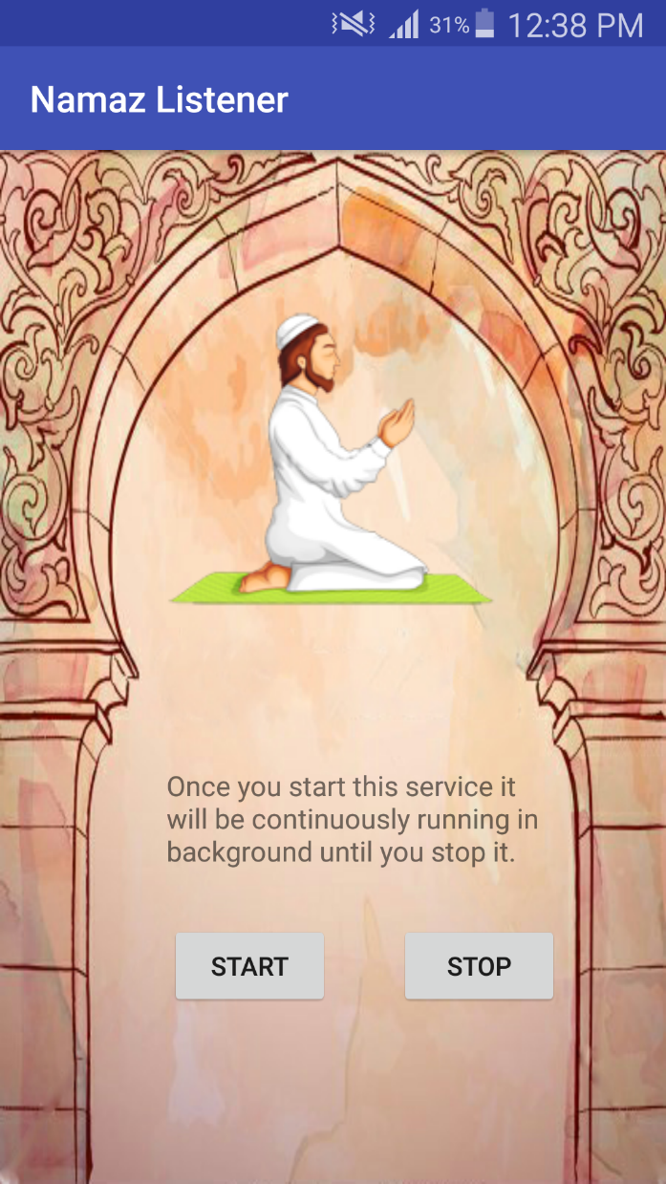

2. To Start Service click on **Start** button.

3. To Stop Service click on **Stop** button

## Settings Required For Namaz app:

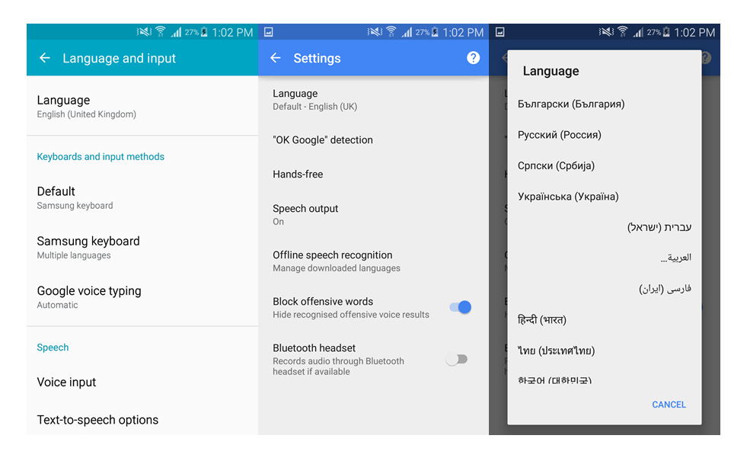

1. Open Wifi
2. Go to Settings 🡪
3. Language and input 🡪 Google voice typing
4. Tap on Language
5. Change Language to Arabic

## Tasbeeh Counter-Home:

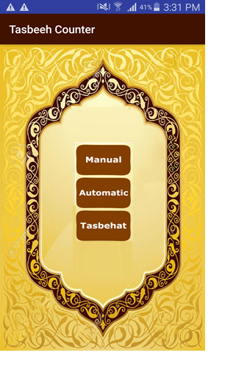

1. For Manual tasbeeh counter click on **Manual** button.
2. For Automatic tasbeeh counter click on **Automatic** button.
3. For Tasbeeh List view/ add custom tasbeeh click on **Tasbehat** button.

## Pick Mode: Manual

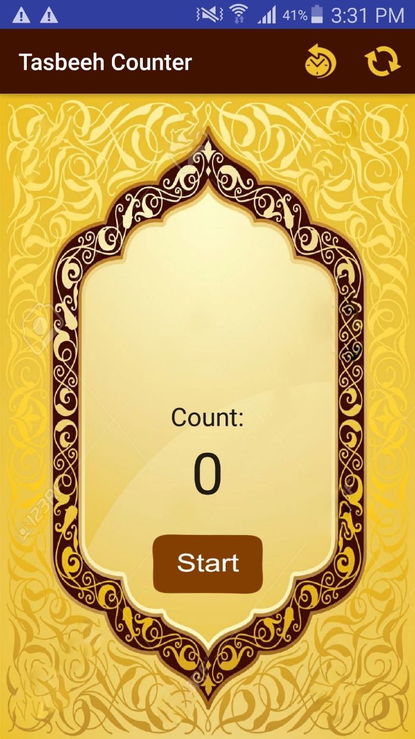

1. After Selecting mode Click on **Start** Button for selecting tasbeeh.

## Select Tasbeeh:

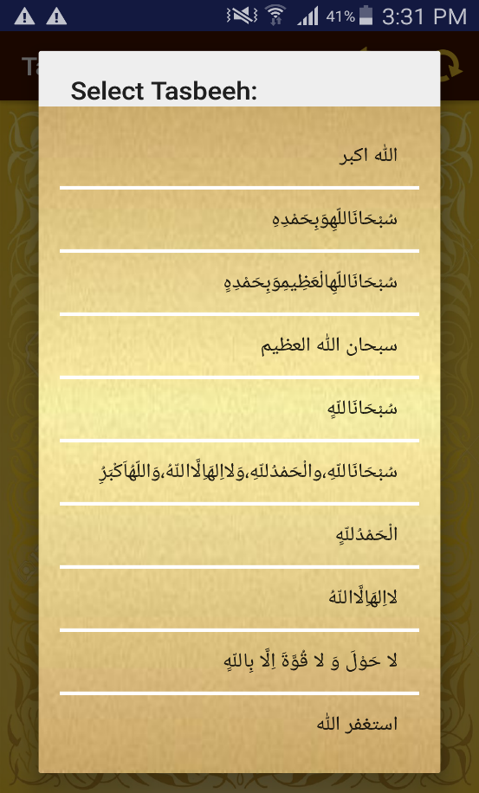

1. These are the default tasbeeh you can select tasbeeh by tapping on the specific tasbeeh.

## Add custom:

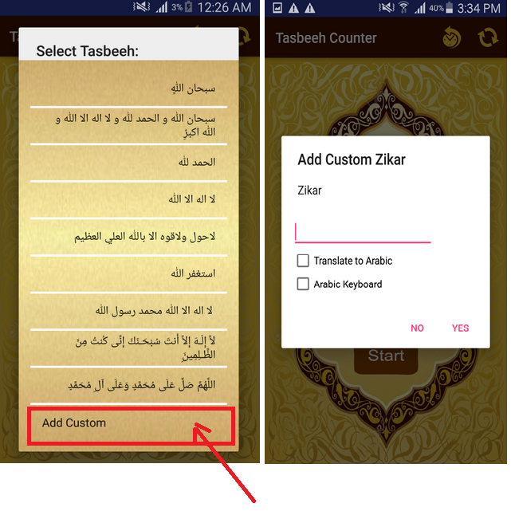

1. Click on **Add Custom** from the list to add custom tasbeeh.
2. You can add custom tasbeeh in Arabic by using these options:

* **Translate to Arabic**
* **Arabic Keyboard**

## Arabic Translator:

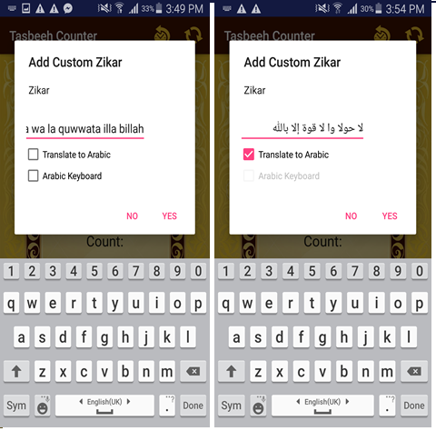

1. For **Translate to Arabic,** write in Roman and check on Translate to Arabic.

## Arabic Keyboard:

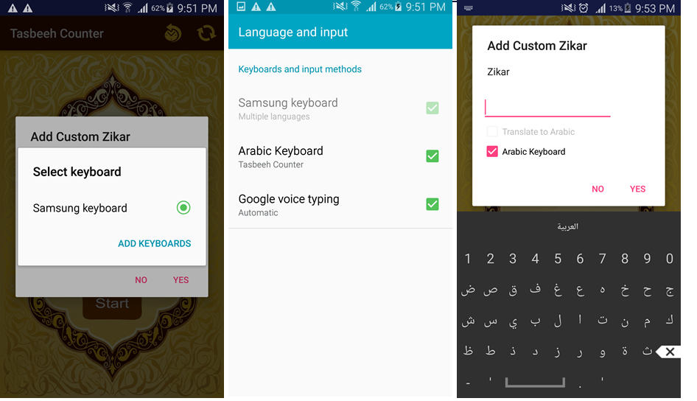

1. Click on **Arabic keyboard** and it will show this popup.
2. Press **add Keyboard**
3. Check on **Arabic Keyboard** tasbeeh counter.
4. After this you will able to use Arabic keyboard to add custom tasbeeh in Arabic.

## Set Counter Limit:

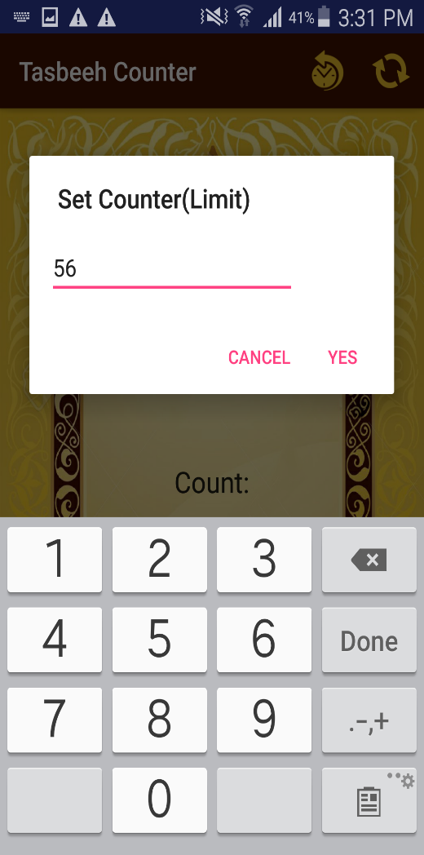

1. Enter the **counter limit**.
2. Press on **Yes** button to continue tasbeeh counting.

## Pick Mode: Automatic

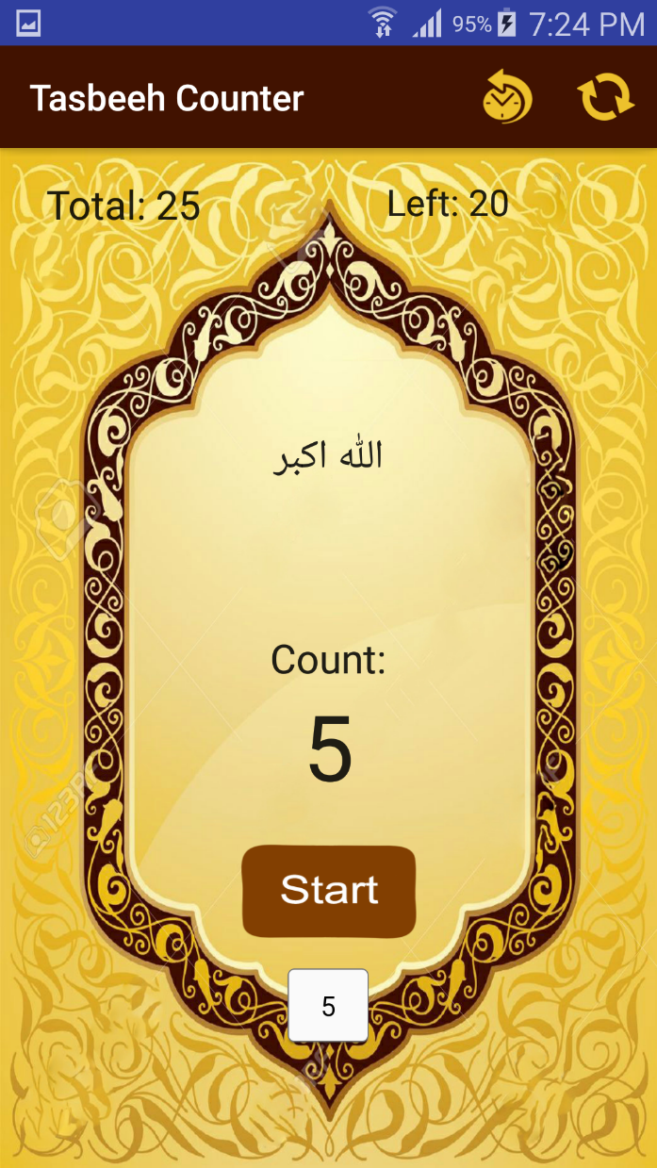

1. By **tapping on the screen** and through **voice** you can count tasbeeh

## History View:

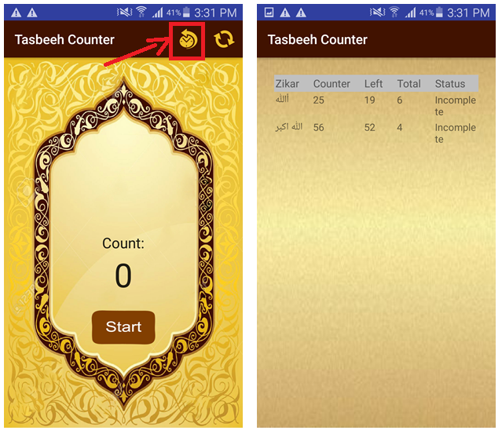

1. For **History View** click on this top icon to check tasbeeh record.

## RESET

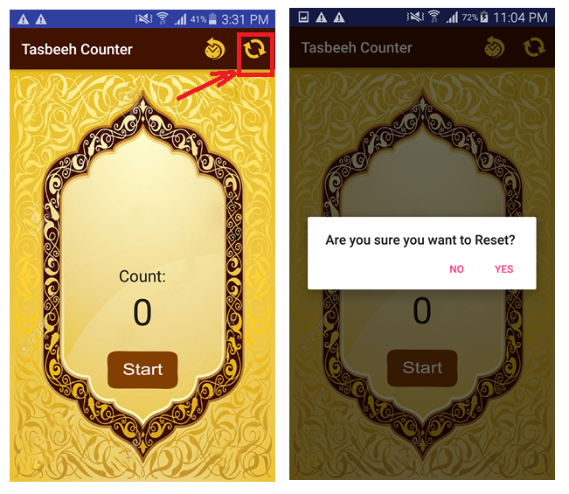

1. To **Reset**, click on the icon right corner to clear onscreen activity.

## Tasbehat

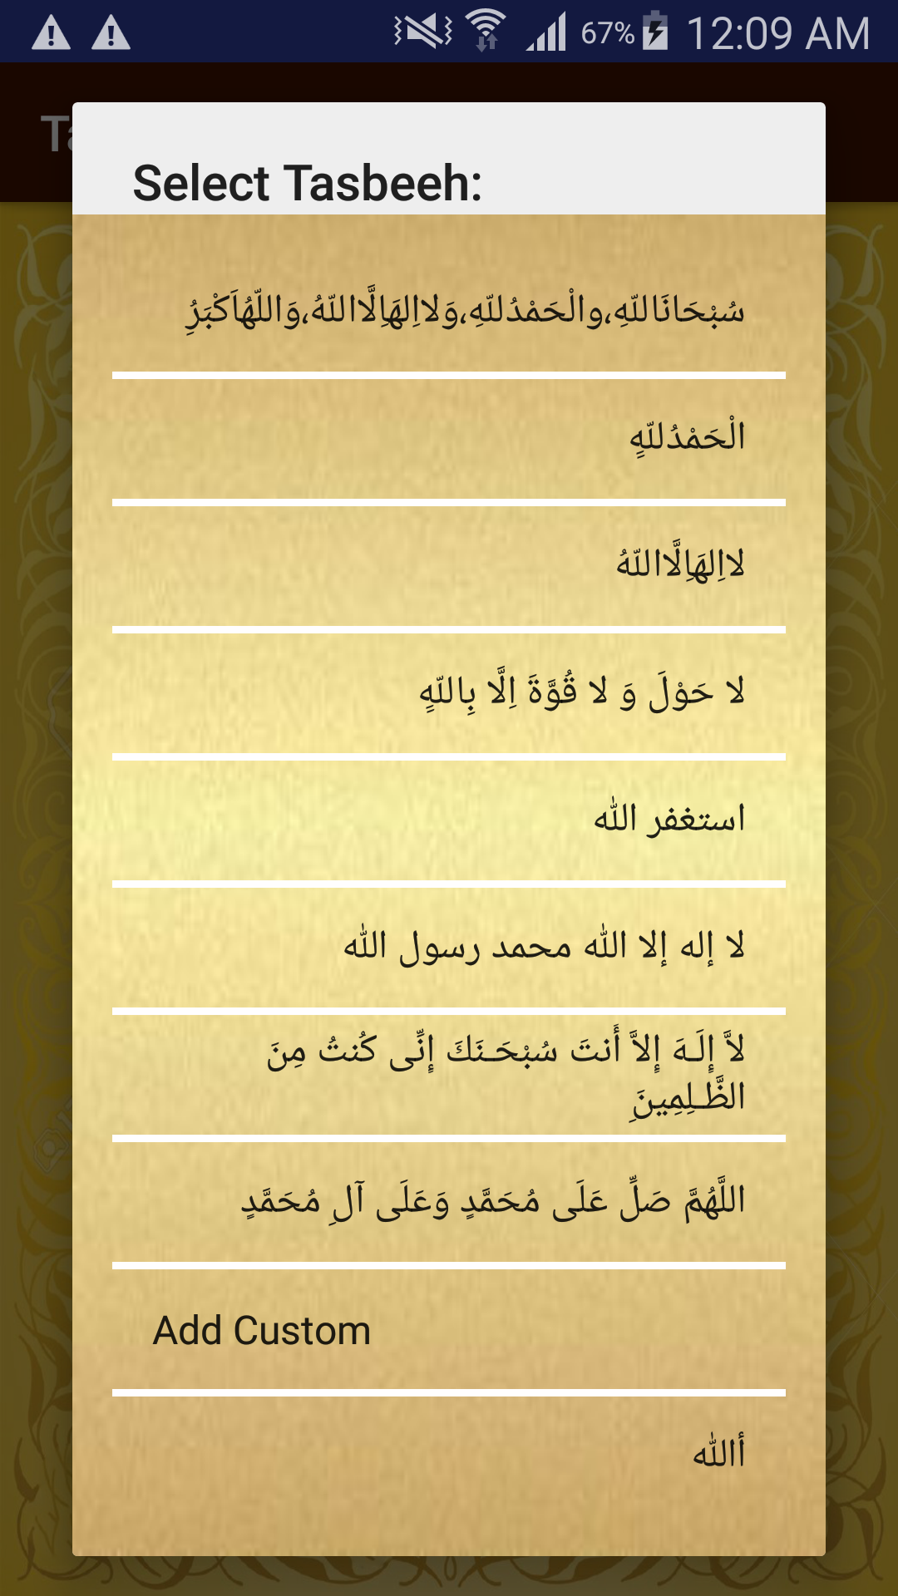

1. You can **add custom** tasbeehonly without selecting tasbeeh mode and view tasbeeh list.

## ISlamic Calendar

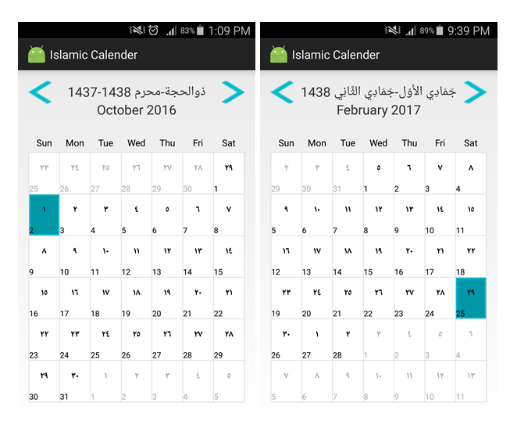

1. Click on Left/Right Button to view next/previous dates and months.
2. Or you can slide left/right to view next/previous dates and months.

## Add Event

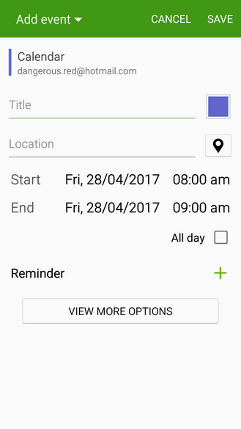

1. **Add Event** by touching on the desired date.

Chapter 5: Glossary

## Glossary

* **AJAX ------------------------------------------------------------Asynchronous JavaScript And XML**
* **OS ------------------------------------------------------------------------------------ Operating System**
* **JSON --------------------------------------------------------------------- JavaScript Object Notation**
* **API ------------------------------------------------------------- Application Programming Interface**
* **GSON ---------------------------------------------------------------------------------------- Java Library**
* **SDK ------------------------------------------------------------------------ Software Development Kit**
* **IDE ---------------------------------------------------------- Integrated Development Environment**
* **FAB ----------------------------------------------------------------------------- Floating Action Button**
* **DDMS ------------------------------------------------------------------ Delvik Debug Monitor Server**
* **GEO -------------------------------------------------------------------- Group On Earth Observations**
* **DWELL ------------------------------------------------------------------------------------- Dot In A Well**
* **HAXM ------------------------------------------------- Hardware Accelerated Execution Manager**
* **AVD ----------------------------------------------------------------------------- Android Virtual Device**